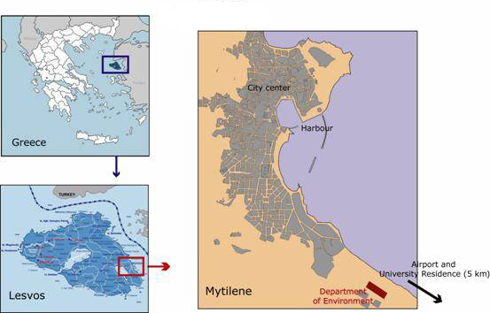

**Transportation**

Taxi:

For taxi reservations call 22510 25900 or 22510 23500.

Taxi stops: several points in the town centre.

Indicative prices for Town – University itinerary: 3,5-4,5€

Reservations are charged with additional 1.5€

You could stop a Taxi in the street by waving your hand at the Taxi Driver. This way the fare will be lower.

Bus:

Blue Bus Time-Table

Departures from Mytilene Centre

|  |  |  |  |  |  |  |  |  |  |  |  |  |
| --- | --- | --- | --- | --- | --- | --- | --- | --- | --- | --- | --- | --- |
| **To** | **Monday - Friday** | | | | | | | | | | | |
| Airport | 06:40 & 7:00 | 07:40 & 08:40 | 09.00-12.00  (every 1 hour) | 12:30 & 13.10 | 14:00 & 14.30 | 15.00 | 15.30 | 16.20 | 17.00 | 18.30 | 19.30 | 20.30 |
| **University\*** | 07:40 | 08.30 | 08:40 | 09.00-19.30  (every 30 minutes) | 20:10 | 20:30 | 21:10 | - | - | - | - | - |
| Agia Marina | 06:40 | 07:40 | 09:00-14:00  (every 1 hour) | 14:45 | 16:20 | 20:10 | - | - | - | - | - | - |
| **From** | **Monday - Friday** | | | | | | | | | | | |
| Airport | +15 minutes after departure from Mytilene | | | | | | | | | | | |
| **University\*** | +10 minutes after departure from Mytilene | | | | | | | | | | | |
| Agia Marina | +20 minutes after departure from Mytilene | | | | | | | | | | | |

* **show your Student ID Card to the driver when you board the bus and will be carried free of charge**

|  |  |  |  |  |  |  |  |  |  |  |  |  |
| --- | --- | --- | --- | --- | --- | --- | --- | --- | --- | --- | --- | --- |
| **To** | **Saturday** | | | | | | | | | | | |
| Airport | 06.40 | 07.30 | 08.15 | 09.00-13.00  (every 1 hour) | 13.40 | 14.30 | 15.15 | 16.15 | 18.15 | 19.15 | 20.10 | - |
| **University** | 13.40 | 14.30 | 16.15 | 19.15 | 20.10 | - | - | - | - | - | - | - |
| Agia Marina | 06:40 | 08:15 | 09:00-13:00  (every 1 hour) | 13:50 | 18:15 | 20:10 | - | - | - | - | - | - |
| **From** | **Saturday** | | | | | | | | | | | |
| Airport | +15 minutes after departure from Mytilene | | | | | | | | | | | |
| University | +10 minutes after departure from Mytilene | | | | | | | | | | | |
| Agia Marina | +20 minutes after departure from Mytilene | | | | | | | | | | | |

|  |  |  |  |  |  |  |  |  |  |  |  |  |
| --- | --- | --- | --- | --- | --- | --- | --- | --- | --- | --- | --- | --- |
| **To** | **Sunday** | | | | | | | | | | | |
| Airport | 09:15 | 11:15 | 13:15 | 15:15 | - | - | - | - | - | - | - | - |
| **University** | 13.15 | 15.15 | - | - | - | - | - | - | - | - | - | - |
| **From** | **Saturday** | | | | | | | | | | | |
| Airport | +15 minutes after departure from Mytilene | | | | | | | | | | | |
| University | +10 minutes after departure from Mytilene | | | | | | | | | | | |
| Agia Marina | +20 minutes after departure from Mytilene | | | | | | | | | | | |

Attention: Bus tickets can only be purchased at local kiosks (“periptera”) and cannot be bought on board. Before entering a bus ask someone if it passes from the University-Πανεπιστήμιο (Xenia).

**Food - University Canteen**

The University Canteen offers breakfast (free of charge), lunch and dinner (total cost: 2,50€/person/day).

The University Canteen is located in the University Hill (Xenia) by the Geography Department Building and it is open seven days a week. Keep in mind that the meals are based on the Greek diet (every Wednesday and Friday vegetarian meals are served)

***Breakfast is served from 08:00-09:30***

***Lunch is served from 12:00 -15:00***

***Dinner is served from 18:00-20:00***

**Fast Food**

The most common option of fast food is Gyros and Souvlaki. You could try:

Pita giro (pork)

Pita giro kotopoulo (chicken)

Pita souvlaki (pork)

Pita souvlaki kotopoulo (chicken)

Pita veg (vegetarian)

There are a few places that will prepare sandwiches.

**Tavernas – Restaurants**

Most of the Tavernas are located at the North part of the city, but you can also find some at the center of the city.

You could try:

Horiatiki (Greek salad: tomatoes, Feta – greek white cheese-, onion, cucumber)

Keftedakia (pork meatballs)

Patates tiganites (French fries)

Gemista (peppers & tomatoes stuffed with rice)

Koutsoumoura (fish)

Sardela (sardine)

Htapodi (octopus)

Kalamaraki (squid)

The prices vary from 15 to 20€ per person

**Pharmacies**

Pharmacies are open from Monday to Friday from 9:00 to 13:30 and from 17:30 to 20:00. Pharmacies remain closed every Monday and Wednesday evening and during weekends. If you need pharmacy services during these hours please contact a facilitator.

**Supermarkets**

Supermarkets are open from 9:00 to 21:00 from Monday to Friday and 9:00 to 20:00 every Saturday.

**Shopping Area**

Ermou St. is the commercial street of Mytilene. There you can find almost everything you need. All commercial shops are open the same hours and days as the pharmacies.

**Public Beach – Tsamakia**

Tsamakia is a Blue Flag awarded beach.

**ATTENTION!!!** Do not step on sea urchins! It’s a really painful experience.

Sea urchins look like this 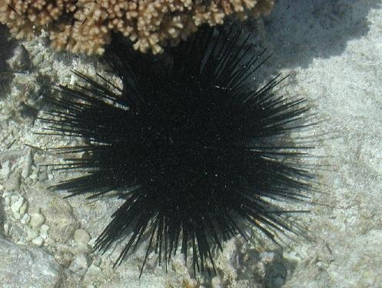

**Laundry-Clothes Washing Facilities**

**5 ά sec** Shop is located at **El. Venizelou 5str**., behind the Bus Station. **5 ά sec,** offers a special pricing for students: **5kgr of clothing costs 5 €.**

**Post Office**

Post office is open from Monday to Friday 8:00 to 13:30.

**Useful phone numbers**

Police: 100

Ambulance: 166